SCHOOL

Trial WACE Examination, 2011

Question/Answer Booklet

MATHEMATICS SPECIALIST 3C/3D
SOLUTIONS

Section Two:

Calculator-assumed

Student Number: In figures

In words

Your name

Time allowed for this section
Reading time before commencing work: ten minutes
Working time for this section: one hundred minutes

Materials required/recommended for this section

To be provided by the supervisor
This Question/Answer Booklet
Formula Sheet (retained from Section One)

To be provided by the candidate
Standard items: pens, pencils, pencil sharpener, eraser, correction fluid/tape, ruler, highlighters

Special items: drawing instruments, templates, notes on two unfolded sheets of A4 paper, and up to three calculators satisfying the conditions set by the Curriculum Council for this examination.

Important note to candidates

No other items may be used in this section of the examination. It is your responsibility to ensure that you do not have any unauthorised notes or other items of a non-personal nature in the examination room. If you have any unauthorised material with you, hand it to the supervisor before reading any further.

Structure of this paper

Section | Number of questions available | Number of questions to be answered | Working time (minutes) | Marks available | Percentage of exam
Section One:  Calculator-free | 6 | 6 | 50 | 40 | 33
Section Two:  Calculator-assumed | 13 | 13 | 100 | 80 | 67
 |  |  | Total | 120 | 100

Instructions to candidates

- The rules for the conduct of Western Australian external examinations are detailed in the Year 12 Information Handbook 2011. Sitting this examination implies that you agree to abide by these rules.

- Write your answers in the spaces provided in this Question/Answer Booklet. Spare pages are included at the end of this booklet. They can be used for planning your responses and/or as additional space if required to continue an answer.
- Planning: If you use the spare pages for planning, indicate this clearly at the top of the page.
- Continuing an answer: If you need to use the space to continue an answer, indicate in the original answer space where the answer is continued, i.e. give the page number. Fill in the number of the question(s) that you are continuing to answer at the top of the page.

- Show all your working clearly. Your working should be in sufficient detail to allow your answers to be checked readily and for marks to be awarded for reasoning. Incorrect answers given without supporting reasoning cannot be allocated any marks. For any question or part question worth more than two marks, valid working or justification is required to receive full marks. If you repeat an answer to any question, ensure that you cancel the answer you do not wish to have marked.

- It is recommended that you do not use pencil, except in diagrams.

Section Two: Calculator-assumed (80 Marks)
This section has thirteen (13) questions. Answer all questions. Write your answers in the spaces provided.

Working time for this section is 100 minutes.

Question 7 (6 marks)
The temperature, °C, of a liquid in an insulated flask at any time seconds can be described by the differential equation 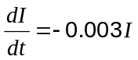.

(a) How long will it take for the liquid in the flask to fall by 10%? (2 marks)

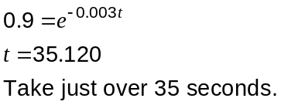

The temperature of a liquid in another, uninsulated, flask is falling exponentially at a percentage decay rate of 0.75%.

(b) If the initial temperatures of the liquids in the insulated and uninsulated flasks are 65°C and 95°C respectively, determine when the difference in temperature between the two liquids is 10°C. (4 marks)
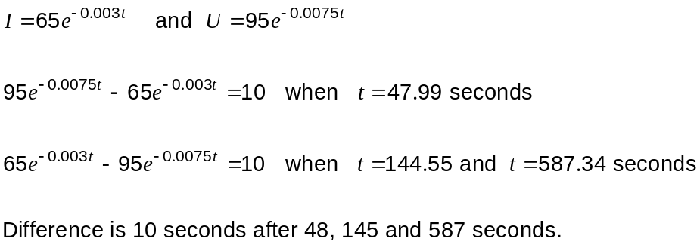

Question 8 (5 marks)
(a) Find the distance between the points with polar coordinates 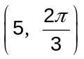 and 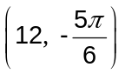, where distances are in centimetres and angles in radians. (2 marks)

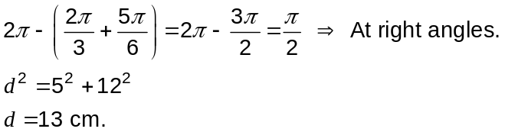

(b) The graphs of 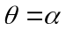 , 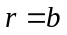 and 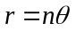 are shown below together with the points A and B which have polar coordinates of 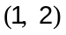 and 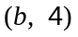. Find the values of 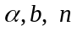 and the polar coordinates of point C. (3 marks)
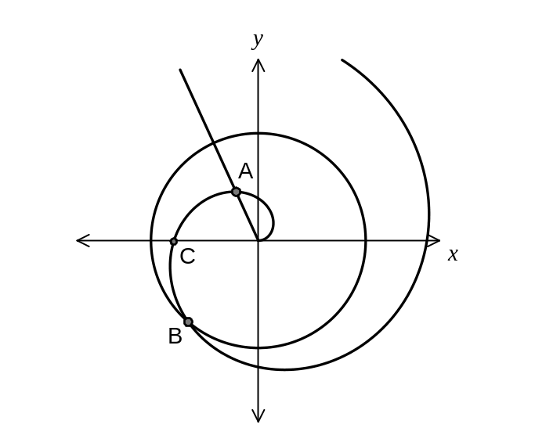
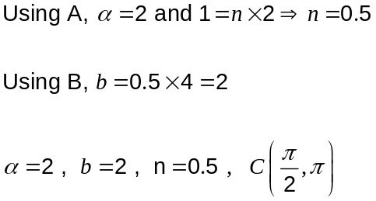

Question 9 (8 marks)
The point has position vector 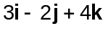.

(a) Find the value of if the vectors 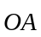 and 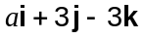 are perpendicular. (1 mark)
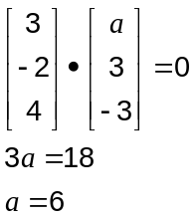

(b) Find the size of the angle between and the -axis, to the nearest degree. (2 marks)
Angle between and the line 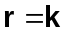

(c) Find the value of if the point (7, , 2) lies in the plane containing the point (-1, 2, 5) and with normal vector . (2 marks)
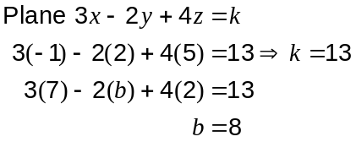

(d) Find the value of if the point (15, -14, ) lies on the straight line through and the point (-1, 2, 5). (3 marks)
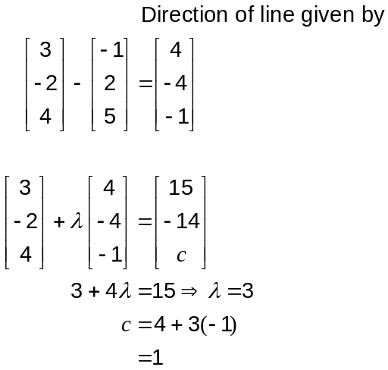

Question 10 (5 marks)
When an object is at a distance cm from a lens of focal length 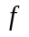cm, an image is formed at a distance of cm from the lens.
The variables are related by the formula 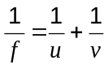.

An object is moving with a constant speed of 2 cm/s towards a lens of focal length 20 cm.

At the instant when the image is 30 cm from the lens, in what direction and with what speed is it moving?
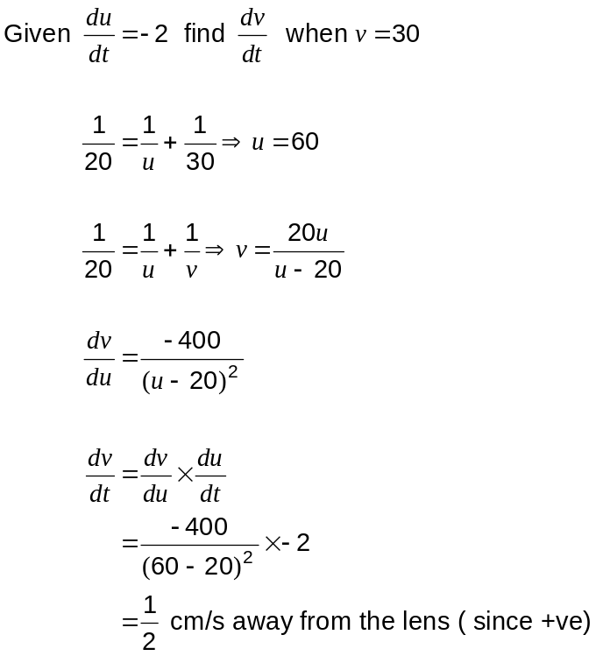

Question 11 (5 marks)
(a) The graph of 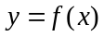 is shown below.
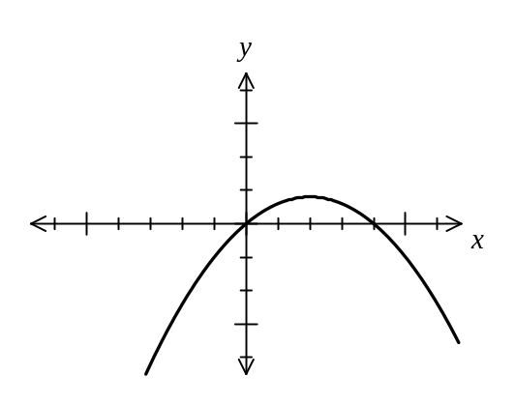

Sketch the graphs of (2 marks)
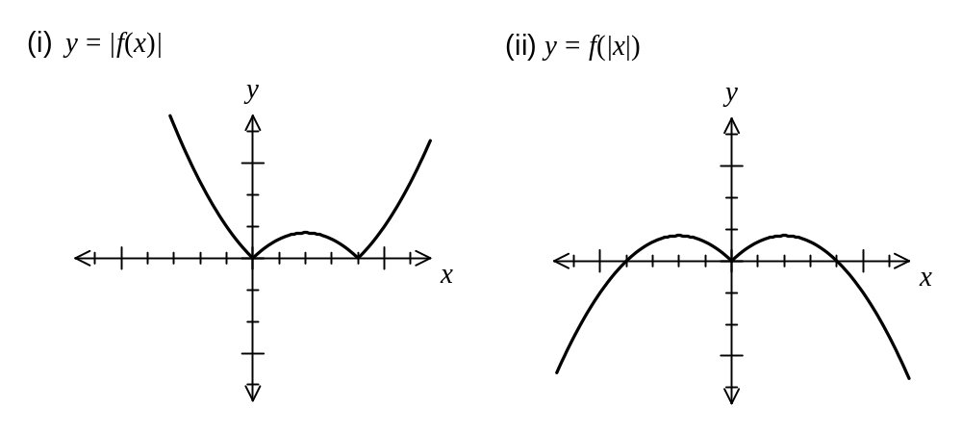

(b) The equation 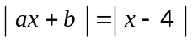 has solutions 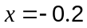 and 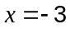. Find the values of and . (3 marks)

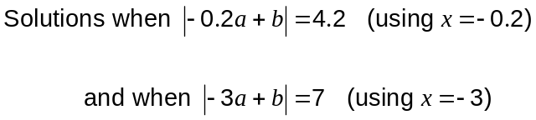

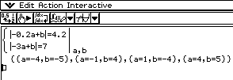

Question 12 (4 marks)
Prove by deduction that 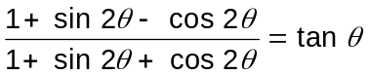.

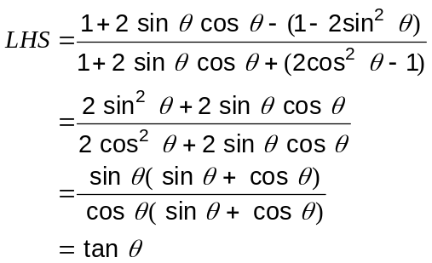

Question 13 (6 marks)
Two complex numbers are given by 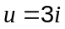 and 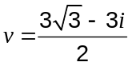.

(a) Express 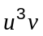 in the form 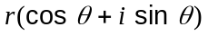 where 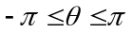 and 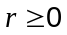. (2 marks)
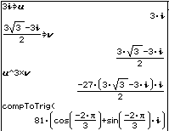

(b) Find all solutions for in the form 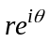, given that 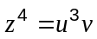. (2 marks)
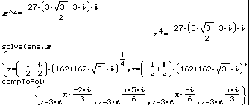

(c) Show that the sum of all the solutions from part (b) is 0. (2 marks)

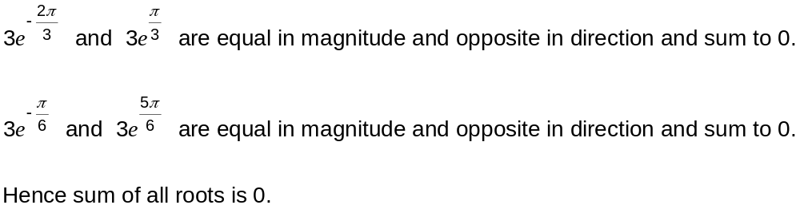

Question 14 (5 marks)
At a school with 108 boarders, boarders can either eat breakfast or not. The canteen manager estimates that of those boarders who eat breakfast one morning, 5% of them will not eat breakfast the next morning and of those boarders who do not eat breakfast one morning, 55% of them eat breakfast the following morning.

(a) If 55 boarders eat breakfast on Monday, how many boarders should the canteen manager expect to eat breakfast on Wednesday? (3 marks)

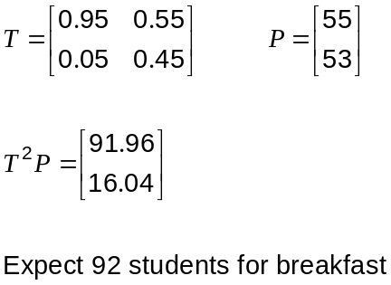

(b) In the long term, what proportion of boarders can be expected to eat breakfast? (2 marks)
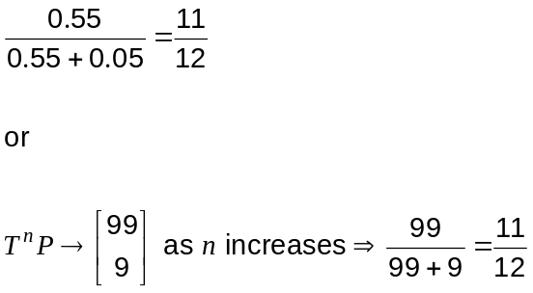

Question 15 (7 marks)
The graphs of the function 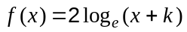, where is a constant, and its inverse 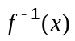, intersect where 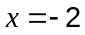 and at one other point.

(a) Find the exact value of . (2 marks)

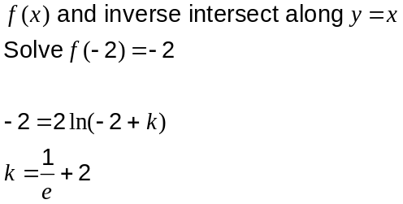

(b) Sketch the graphs of  and its inverse on the axes below, giving equations of any asymptotes and showing the coordinates of all points of intersection and axes-intercepts correct to 2 decimal places. (5 marks)
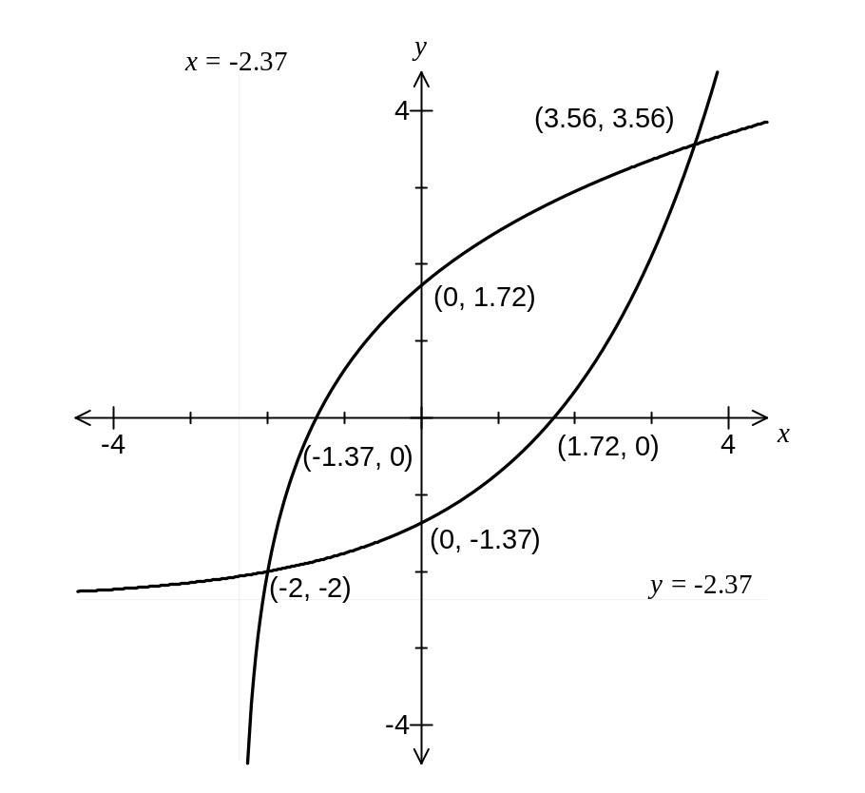

Question 16 (5 marks)
(a) The matrix equation 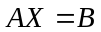could be used to solve the following system of equations.

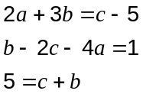

Write down suitable matrices for 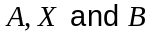. (DO NOT SOLVE YOUR EQUATIONS)
(2 marks)
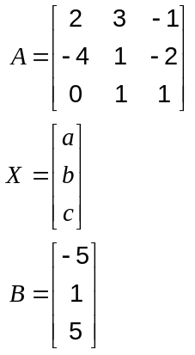

(b) If 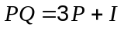 where 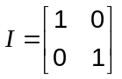 and 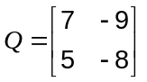, find matrix . (3 marks)

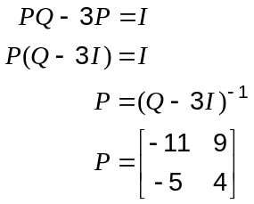

Question 17 (7 marks)
The displacement 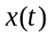metres, of a small particle undergoing simple harmonic motion is given by 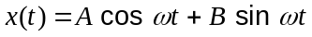, where 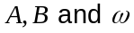 are positive constants.

(a) Show that 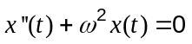. (2 marks)
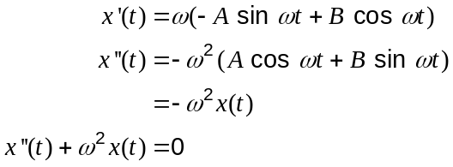

The body passes through the origin (where 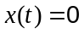) five times per second, 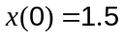m and 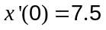ms⁻¹.

(b) Find the exact values of the constants . (3 marks)
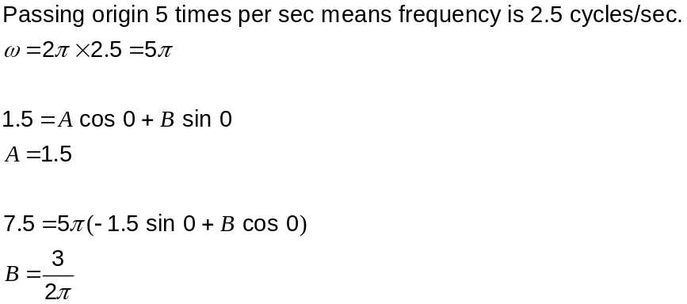

(c) What is the amplitude of motion, correct to the nearest millimetre? (2 marks)
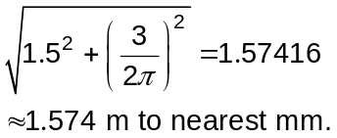

Question 18 (8 marks)
Every odd integer can be written as 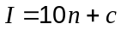, where 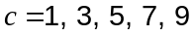.

(a) Show how the integers 237, 3 and -35 can be written this way. (1 mark)

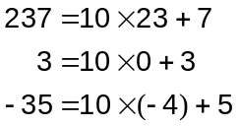

(b) By considering the five different cases for , or otherwise, prove that the square of every odd integer ends in 1, 5 or 9. (7 marks)

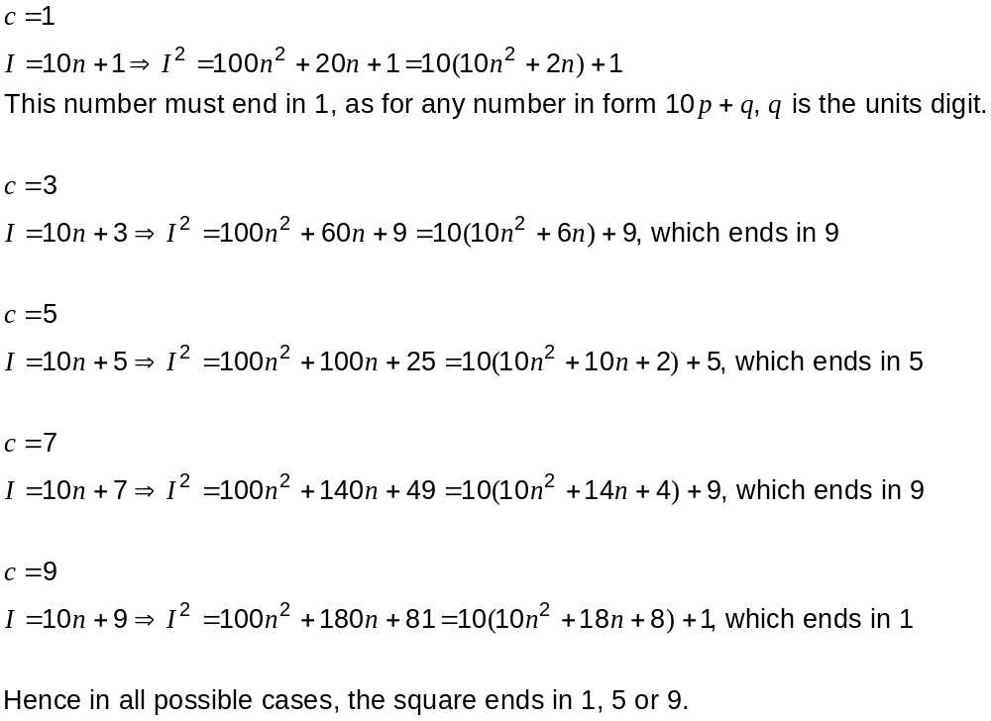

Question 19 (9 marks)
Relative to itself, an anti-ballistic missile (ABM) launch site detects a ballistic missile at 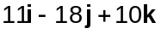 km headed at constant velocity for a target at 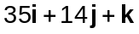 km. The ballistic missile is expected to hit the target in 50 seconds.

(a) How close does the ballistic missile come to the ABM launch site? (5 marks)
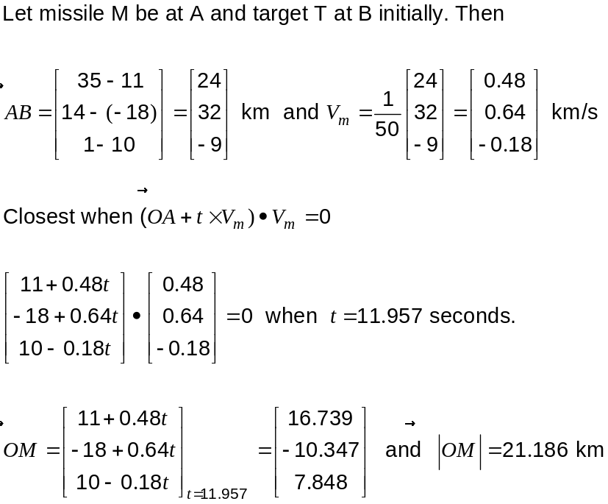

(b) The launch site plans to fire an ABM to hit the ballistic missile. The hit is timed to take place at the instant the ballistic missile comes within 8km of the target. Assuming the ABM instantly achieves a constant velocity of 1150 ms⁻¹ as it is launched, how long from the time of detection should the defence site fire it? (4 marks)

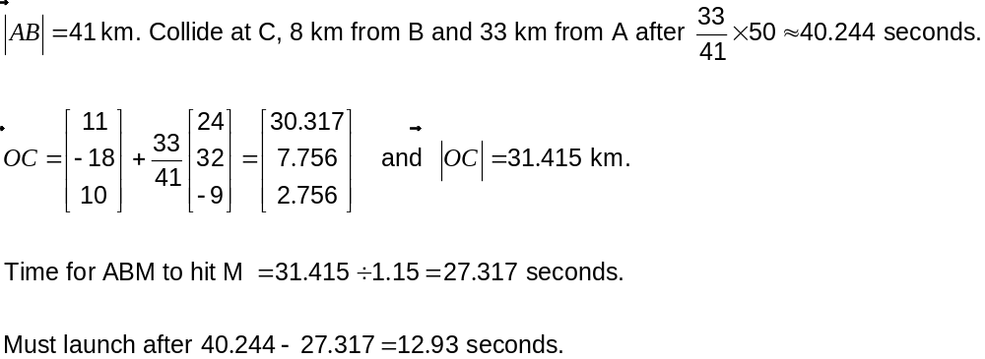

This examination paper may be freely copied, or communicated on an intranet, for non-commercial purposes within educational institutes that have purchased the paper from WA Examination Papers provided that WA Examination Papers is acknowledged as the copyright owner. Teachers within purchasing schools may change the paper provided that WA Examination Paper's moral rights are not infringed.

Copying or communication for any other purposes can only be done within the terms of the Copyright Act or with prior written permission of WA Examination papers.

Published by WA Examination Papers
PO Box 445 Claremont WA 6910

